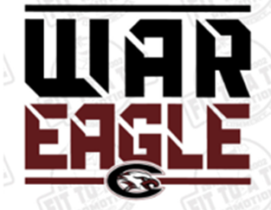
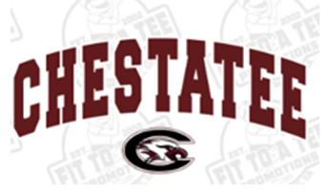
CHESTATEE SPIRITWEAR ORDER FORM
DUE OCTOBER 3rd Turn into Front Office or Coach Boyd
Make checks payable to: CHESTATEE ACADEMY
Design 1
Design 2

Name: ______________________ 1st Period Teacher: _______________ Phone: __________________
Gildan Short Sleeve T-Shirt
ITEM | SIZE | DESIGN 1 | DESIGN 2 | PRICE | QUANITIY
White T-shirt | YM YL S M L XL *XXL |  |  | $12.00
Grey T-shirt | YM YL S M L XL *XXL |  |  | $12.00
Black T-shirt | YM YL S M L XL *XXL |  |  | $12.00
TOTAL AMOUNT DUE ( **+$2.00 for XXL**)

Gildan Soft Style Short Sleeve and Long Sleeve T-Shirt
ITEM | SIZE | DESIGN 1 | DESIGN 2 | PRICE | QUANITIY
Grey Short Sleeve | YM YL S M L XL *XXL |  |  | $14.00
Black Short Sleeve | YM YL S M L XL *XXL |  |  | $14.00
Grey Long Sleeve | S M L XL *XXL |  |  | $16.00
Black Long Sleeve | S M L XL *XXL |  |  | $16.00
TOTAL AMOUNT DUE ( *+$2.00 for XXL*)

Anvil Lightweight Hooded Long Sleeve T-Shirt
ITEM | SIZE | DESIGN 1 | DESIGN 2 | PRICE | QUANITIY
White | YM YL S M L XL *XXL |  |  | $24.00
Black | YM YL S M L XL *XXL |  |  | $24.00
TOTAL AMOUNT DUE ( *+$2.00 for XXL*)

Gildan Hoodie Sweatshirt
ITEM | SIZE | DESIGN 1 | DESIGN 2 | PRICE | QUANITIY
White | YM YL S M L XL *XXL |  |  | $25.00
Grey | YM YL S M L XL *XXL |  |  | $25.00
Black | YM YL S M L XL *XXL |  |  | $25.00
TOTAL AMOUNT DUE ( *+$2.00 for XXL*)

Badger Pocket Crew Sweatshirt
ITEM | SIZE | DESIGN 1 | DESIGN 2 | PRICE | QUANITIY
Grey | S M L XL *XXL |  |  | $30.00
Black | S M L XL *XXL |  |  | $30.00
TOTAL AMOUNT DUE ( *+$2.00 for XXL*)

