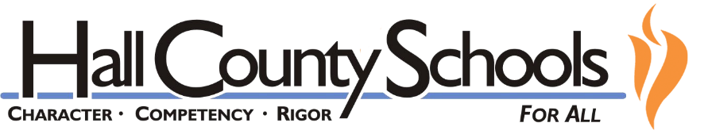

Grading and End-of-Year Grades
2019-2020

IMPORTANT DATES
May 7, 2020 | Last Day of New Student Assignments
May 8, 2020 | Grading Windows Open
May 8 – May 22, 2020 | Student Remediation & Student Work Accepted
May 27, 2020 | Last Day of School for 190-day Employees

K-12 Hold Harmless Provision: The lack of participation and/or poor achievement with School-From Home Learning will NOT impact student grading in a negative manner.

ELEMENTARY SCHOOLS

Grades
- Elementary teachers will document mastery of standards with a Pass (P) or Retention Consideration (RC) for both the 4th nine weeks and final averages.
- After May 7th, teachers will have the opportunity to reconcile student assignments, work with their most at-risk students, and address End-of-Year procedures.

Retention/Promotion

- Unless unique circumstances existed prior to School-from-Home, elementary students will be promoted to the next grade level.
- Promoted students may need additional remediation support during the 2020-2021 school year.

MIDDLE SCHOOLS

Grades

- Middle school students will receive numerical grades. School-from-Home performance can and often will positively impact student grades.
- After May 7th, teachers will have the opportunity to reconcile student assignments, work with their most at-risk students, and address End-of-Year procedures.
- For semester and yearlong classes, the 4th nine weeks grade will be equal to or higher than the 3rd nine weeks final average.
- For nine-week classes, the 4th nine weeks grade will be the School-from-Home average. The lowest possible grade will be a 70.
- Carnegie Unit courses will follow high school grading guidance.

Retention/Promotion

- Unless unique circumstances existed prior to School-from-Home, middle school students will be “promoted” to or “placed” into the next grade level.
- “Placed” students may need additional remediation support during the 2020-2021 school year.
HIGH SCHOOLS

Grades

- High school students will receive numerical grades. School-from-Home performance can and often will positively impact student grades.
- After May 7th, teachers will have the opportunity to reconcile student assignments, work with their most at-risk students, and address End-of-Year procedures.
- For semester and yearlong classes, students will receive a 2nd semester final average grade that is equal to or higher than the grade on record as the 3rd Term progress calculation.
- There will be no spring final exams nor EOC exams. Therefore, the 20% EOC exam calculation will be coded as EXEMPT for these courses.
- Note: AP and IB Exam scores are administered separately by the College Board and the International Baccalaureate Programme; these exam scores do not impact student grades. Teachers may continue to hold ungraded review sessions to help students prepare.

Retention/Promotion

- Student promotion for high school students will continue to be determined by earned Carnegie credits.
- Seniors who had failed to meet graduation requirements before School-from-Home will be able to work through May 22nd (with no new assignments) to qualify for graduation.
- Summer School opportunities will be available to all high school students who need to earn or recover credits needed for graduation.

